the biography of

George Seferis

A Greek poet and diplomat
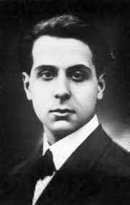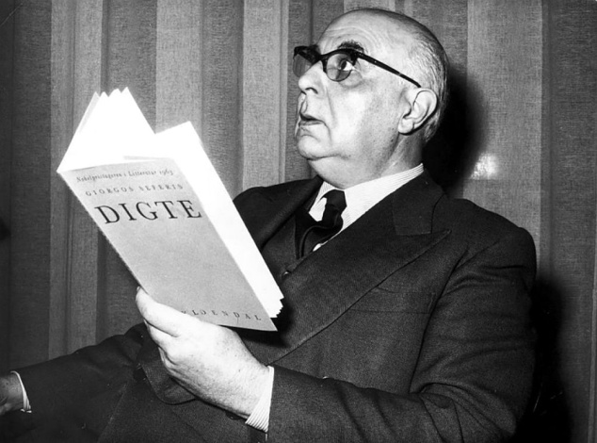
Giorgos Seferis the pen name of Gieorgios Seferiadis. He was born in February 29 1900 in Izmir, Turkey. His father, Stelios Seferiadis, was a lawyer and later a professor at the University of Athens. Both of these attitudes influenced his son.
In 1914 his family moved to Athens. After completing his schooling he studied law in Sorbonne, Paris 1918. When he returned to Athens Seferis joined the diplomatic corps and began a successful career that sent him to England and then Albania. During the war he worked with the free Greek movement and only returned to the capital when the war in Greece was about to end.
He had published works during the 30s and 40s including his debut Strophe in 1931 and Cistern which were influenced by Hellenistic culture and Greek history. In 1947 he published The Thrush whilst holding a diplomatic post in Turkey. In 1953, Seferis paid his first visit to Cyprus and fell deeply in love with the island which reminded him a great deal of his childhood with its mix of people and rolling landscape.
In 1963 Seferis became the first National to be awarded the Nobel Prize for literature which recognized the role he had played in the revival of Greek writing and culture. He died in September 1971 at the age of71.

Source: mypoeticside.com, poetryfoundation.org, el.wikipedia.org, aiorabooks.com, theparisreview.org
By Electra Lahanoudi Papadopoulou Γ3

