WILLIAM SHAKESPEARE
A project made by Nikolas Tselezidis

William Shakespeare was born and baptized in Stratford-upon-Avon, England at the 26th of April in 1564. He was raised there with his parents John Shakespeare and Mary Arden.

At 18 years old he married Anne Hathaway and had 3 children with her, Susanna, Hamnet and Judith. The last two were twins. His was a playwright, a poet and an actor.
Shakespeare's career took off between 1585 and 1592. At the time he was an actor, writer and part owner of a playing company called the Lord Chamberlain's Men later known as the King’s Men

He produced most of his works between 1589 and 1613. His early plays were mostly comedies an histories and are regarded as some of the best works in these genres. He then mainly wrote tragedies until 1608. His greatest accomplishments are: Hamlet, Romeo and Juliet , Othello, King Lear, Macbeth and are all considered to be among the finest works in the English language.

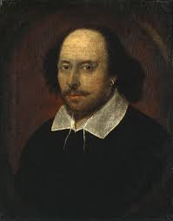
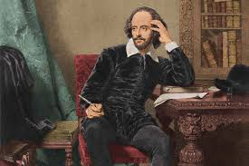
In the last phase of his career he wrote tragicomedies (also known as romances) and collaborated with other playwrights. William Shakespeare died at the 23rd of April in 1616 at the age of 52 years old at the same place where he was born (Stratford-upon-Avon, England).

