Alki Zei
Alki Zei was born in Athens in 1923 and was a prose writer and author. She studied theater philosophy and acting.
Her relationship with writing began in her high school years, writing works for the theater. In 1963, she wrote her first book, "the chaplain of the shop window". Some of her books contain historical events since she wrote them during the occupation of Greece. Her books are mainly for children and teenagers.
She has been awarded many times. For example, she has received the American award for the best children's book, the state award for children's book, the Italian award and the Ourani award for her entire work.
She died in 2020 in Athens at the age of 96.

The Great walk of Petros
The Walk of Petros is a children's/adolescent novel by Alki Zei published in 1971. The novel has a historical content and presents a boy named Petros who at the age of 9 lives in Athens occupied by the Germans.
It is an emotional book that is definitely worth reading.
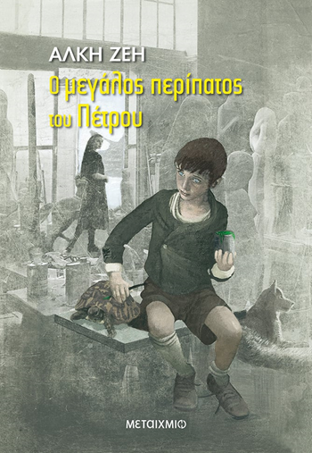 Δήμητρα Καλάκια Γ2

