GIORGOS SEFERIS
BIOGRAPHY
BY ANNA SAMARA
Seferis was born in Vourla near Smyrna in Asia Minor, in the Aidin Vilayet of the Ottoman Empire (now İzmir, Turkey). His father, Stelios Seferiadis, was a lawyer, and later a professor at the University of Athens, as well as a poet and translator in his own right. He was also a staunch Venizelist and a supporter of the demotic Greek language over the formal, official language (katharevousa). Both of these attitudes influenced his son. In 1914 the family moved to Athens, where Seferis completed his secondary school education. He continued his studies in Paris from 1918 to 1925, studying law at the Sorbonne. While he was there, in September 1922, Smyrna/Izmir was taken by the Turkish Army after a two-year Greek military campaign on Anatolian soil. Many Greeks, including Seferis's family, fled from Asia Minor. Seferis would not visit Smyrna again until 1950; the sense of being an exile from his childhood home would inform much of Seferis's poetry, showing itself particularly in his interest in the story of Odysseus.
Wandering and exile are present in Seferis’s poetry, and his work is attuned to the history of Greece—the Nobel Prize committee recognized him as a “representative Hellenic poet.” His poetry often intertwines contemporary speech and experience with Homeric myth, and many of his poems depict the landscape of the Mediterranean. In their foreword to George Seferis: Collected Poems (1995), translators Edmund Keeley and Philip Sherrard noted: “The distinguishing attribute of Seferis’s genius—one that he shares with Yeats and Eliot—was always his ability to make out of a local politics, out of a personal history or mythology, some sort of general statement or metaphor.
Giorgos Seferis’ many travels as a diplomat provide the backdrop for much of his writing, which is filled with themes of alienation, wandering, and death. His first collection of poems, Turning Point, was published in 1931. Seferis’ later poetry ¬– e.g., Mythistorema (1935) and Imerologio Katastromatos I–III (1940–1955) (Logbook I–III)– often intertwines contemporary speech and experience with Homeric myth.

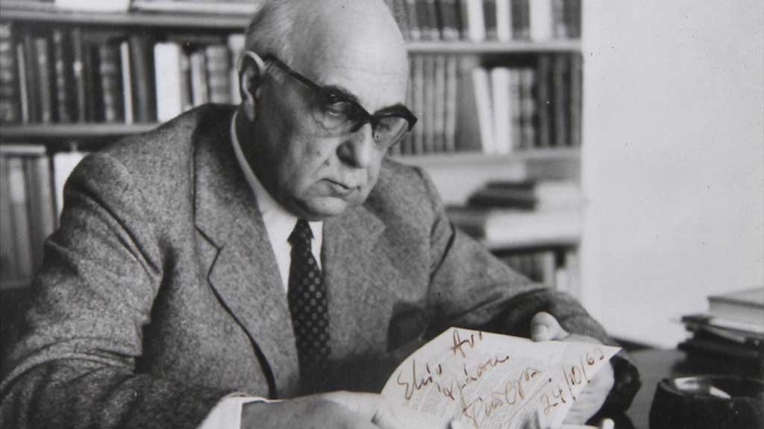

Our Sun
This sun was mine and yours; we shared it.
Who's suffering behind the golden silk, who's dying?
A woman beating her dry breasts cried out; `Cowards,
they've taken my children and torn them to shreds, you've
killed them
gazing at the fire-flies at dusk with a strange look,
lost in blind thought.'
The blood was drying on a hand that a tree made green,
a warrior was asleep clutching the lance that cast light
against his side.
It was ours, this sun, we saw nothing behind the gold
embroidery
then the messengers came, dirty and breathless,
stuttering unintelligible words
twenty days and nights on the barren earth with thorns only
twenty days and nights feeling the bellies of the horses
bleering
and not a moment's break to drink rain-water.
You told them to rest first and then to speak, the light had
dazzled you.
They died saying `We don't have time', touching some rays
of the sun.
You'd forgotten that no one rests.
A woman howled `Cowards'. like a dog in the night.
Once she would have been beautiful like you
with the wet mouth, veins alive beneath the skin,
with love.
This sun is ours; you kept all of it, you wouldn't follow
me.
And it was then I found about those things behind the
gold and the silk:
we don't have time. The messengers were right.

“Στροφή”
Στιγμή, σταλμένη ἀπὸ ἕνα χέρι
ποὺ εἶχα τόσο ἀγαπήσει
μὲ πρόφταξες ἴσια στὴ δύση
σὰ μαῦρο περιστέρι.
Ὁ δρόμος ἄσπριζε μπροστά μου,
ἁπαλὸς ἀχνὸς ὕπνου
στὸ γέρμα ἑνὸς μυστικοῦ δείπνου…
Στιγμὴ σπυρὶ τῆς ἄμμου,
ποὺ κράτησες μονάχη σου ὅλη
τὴν τραγικὴ κλεψύδρα
βουβή, σὰ νὰ εἶχε δεῖ τὴν Ὕδρα
στὸ οὐράνιο περιβόλι.

